Bank transactions analysis using SQL
Overview
Bank transaction analysis monitors on the unusual patterns and financial risks. It monitors the customer behavior analyzing the patterns between accounts, transactions and customers. This project is build using SQL to identify the risk rate, high valued withdrawals and loan risk.
By the end of project, we can conclude:
- High valued transactions
- Unusual spikes
- Loan defaults
- Abnormal spending behavior
Objectives
- Use window function (LAG, LEAD)
- Suspicious transaction summary
- Fraud detection logic
- SQL queries
Data setup
This project mainly contains 4 tables.
Table | Columns name
Customers | customer  customer name  city  join date  credit score
Transactions | transaction  account  transaction date  transaction hour  amount,  transcation_type,  category  foreign key(account)
Accounts | account  customer  account type  opening balance  status  foreign key
Loans | loan_id  customer  principal amount  interest rate  issue date  status foreign key(customer)

Data size
Customers | 150
transactions | 400
Account | 130
Loans | 60

Spike detection with AVG () OVER analysis
WITH txn_with_avg AS (
SELECT
t.*,
AVG(amount) OVER (PARTITION BY account) AS account_avg_amount
FROM transactions t
)
SELECT
account,
transaction,
transaction date,
transaction hour,
amount,
ROUND(account_avg_amount, 2) AS account_avg_amount,
ROUND(amount / NULLIF(account_avg_amount, 0), 1) AS times_average
FROM txn_with_avg
WHERE amount >= 5 * account_avg_amount
ORDER BY times_average DESC;
NTILE with hour value transactions
WITH ranked AS (
SELECT *, NTILE(100) OVER (ORDER BY amount) AS percentile
FROM transactions
)
SELECT account_id, transaction_id, transaction_date, amount, category
FROM ranked
WHERE percentile = 100
ORDER BY amount DESC;
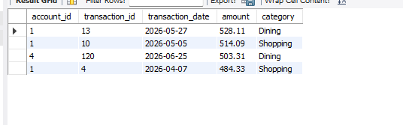
RISK classifications
WITH acc_stats AS (
SELECT
account_id,
COUNT(*) AS txn_count,
ROUND(AVG(amount), 2) AS avg_amount,
MAX(amount) AS max_amount,
SUM(CASE WHEN transaction_hour BETWEEN 0 AND 5 THEN 1 ELSE 0 END) AS odd_hour_txns
FROM transactions
GROUP BY account_id
),
spike_flags AS (
SELECT account_id, COUNT(*) AS spike_count
FROM (
SELECT t.*, AVG(amount) OVER (PARTITION BY account_id) AS acct_avg
FROM transactions t
) x
WHERE amount >= 5 * acct_avg
GROUP BY account_id
)
SELECT
a.account_id,
a.txn_count,
a.avg_amount,
a.max_amount,
a.odd_hour_txns,
COALESCE(s.spike_count, 0) AS spike_count,
CASE
WHEN COALESCE(s.spike_count, 0) >= 1 AND a.odd_hour_txns >= 1 THEN 'High'
WHEN COALESCE(s.spike_count, 0) >= 1 OR a.odd_hour_txns >= 2 THEN 'Medium'
ELSE 'Low'
END AS risk_level
FROM acc_stats a
LEFT JOIN spike_flags s ON a.account_id = s.account_id
ORDER BY risk_level, a.max_amount DESC;

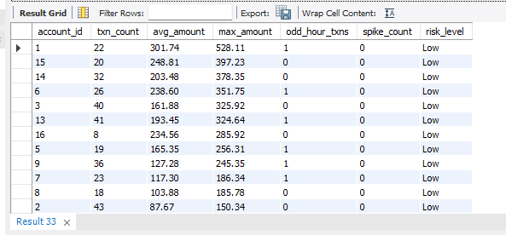
Loan default risk
SELECT
CASE
WHEN c.credit_score < 580 THEN 'Poor (<580)'
WHEN c.credit_score < 670 THEN 'Fair (580-669)'
WHEN c.credit_score < 740 THEN 'Good (670-739)'
ELSE 'Excellent (740+)'
END AS credit_band,
COUNT(*) AS total_loans,
SUM(CASE WHEN l.status = 'Defaulted' THEN 1 ELSE 0 END) AS defaults,
ROUND(100.0 * SUM(CASE WHEN l.status = 'Defaulted' THEN 1 ELSE 0 END) / COUNT(*), 2) AS default_rate_pct
FROM loans l
JOIN customers c ON l.customer_id = c.customer_id
GROUP BY credit_band
ORDER BY default_rate_pct DESC;
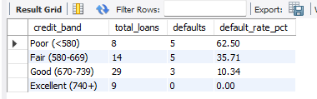

Reporting summary
SELECT
ROUND(SUM(principal_amount), 2) AS total_defaulted_principal,
COUNT(*) AS defaulted_loan_count
FROM loans
WHERE status = 'Defaulted';

WITH spike_flags AS (
SELECT account_id, COUNT(*) AS spike_count, MAX(amount) AS largest_spike
FROM (
SELECT t.*, AVG(amount) OVER (PARTITION BY account_id) AS acct_avg
FROM transactions t
) x
WHERE amount >= 1 * acct_avg
GROUP BY account_id
)
SELECT
c.customer_id,
c.customer_name,
sf.account_id,
sf.spike_count,
sf.largest_spike
FROM spike_flags sf
JOIN accounts a ON sf.account_id = a.account_id
JOIN customers c ON a.customer_id = c.customer_id
ORDER BY sf.largest_spike DESC;

SELECT
date_format('%Y-%m', transaction_date) AS txn_month,
COUNT(*) AS txn_count,
ROUND(SUM(amount), 2) AS total_volume
FROM transactions
GROUP BY txn_month
ORDER BY txn_month;

SELECT
category,
COUNT(*) AS txn_count,
ROUND(SUM(amount), 2) AS total_volume
FROM transactions
GROUP BY category
ORDER BY total_volume DESC;

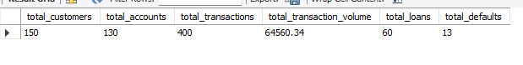

Transaction category
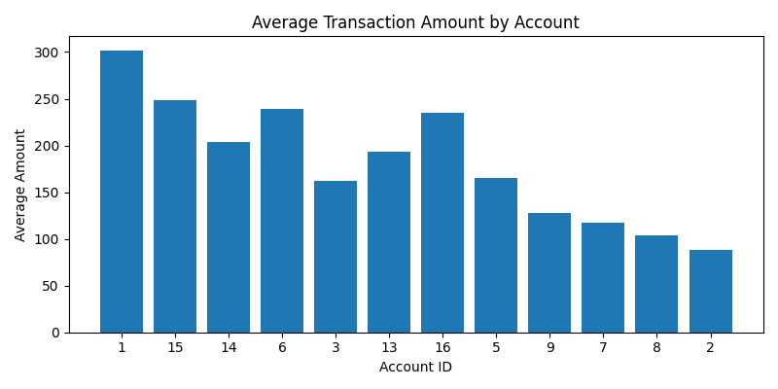
Key recommendations
- Implement Real-Time Transaction Monitoring
Continuously monitor account activity to identify suspicious transactions as they occur.
- Set Dynamic Transaction Thresholds
Configure transaction limits based on customer spending behavior rather than fixed values.
- Monitor High-Frequency Transactions
Accounts with an unusually high number of transactions within a short period should be reviewed.
- Track Large Transaction Amounts
Flag transactions that significantly exceed the customer's average transaction value.
Conclusion
The Bank Transaction Analysis project shows how SQL and data analytics can help watch over customer transactions, spot unusual activity, and aid in detecting fraud.
By looking at things like the number of transactions, average and highest transaction amounts, and risk signals, the bank can make better decisions to improve security, lower financial risks, and build more trust with customers.Using automatic monitoring, real-time alerts, and interactive dashboards will make fraud prevention stronger and make the bank's operations more efficient.

